Athlete Account Creation on COYESS Tournament Website
This site is new. If you encounter any issues or have any questions when using this site please contact Jason Nester at 303 883 7490.

Please follow the instructions below on how to create your athlete account on the COYESS Tournament website. This setup will cover creating your athlete account, searching available teams, and requesting to be added to a team. If you plan to compete only as an individual, then you do not need to complete the team request part of the instructions below.

Even if you are assigned to a team you can always register for any tournament as an individual and compete individually.

Go to the COYESS website (Colorado Youth Education in Shooting Sports) and select the “Events” link. Then select the Register for Tournaments link.

Or go directly to the Tournament website (COYESS Tournaments).
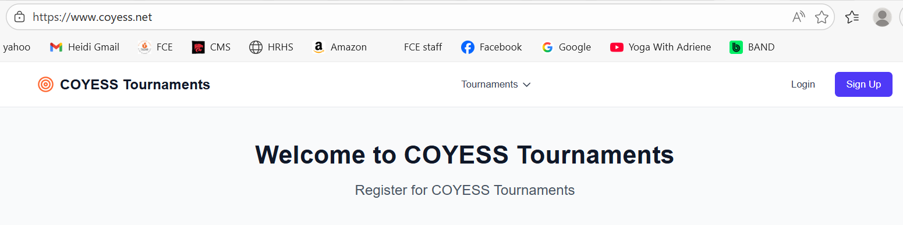

To create a new athlete account, select the “Sign Up” button in the top right corner.
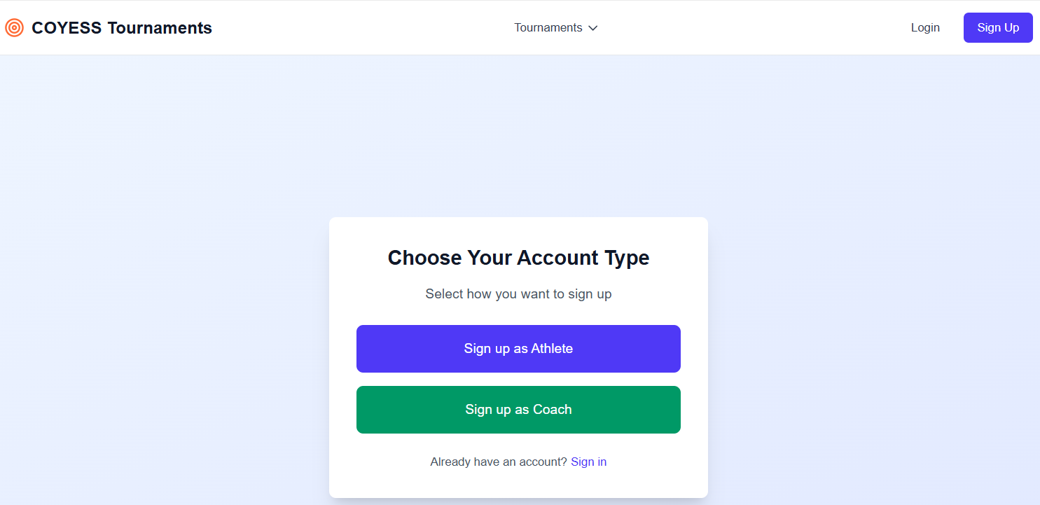

Select the “Sign up as Athlete” button.

Enter key information including a secure password for your login. Once you have filled in all the details, select the “Create Athlete Account” button at the bottom.
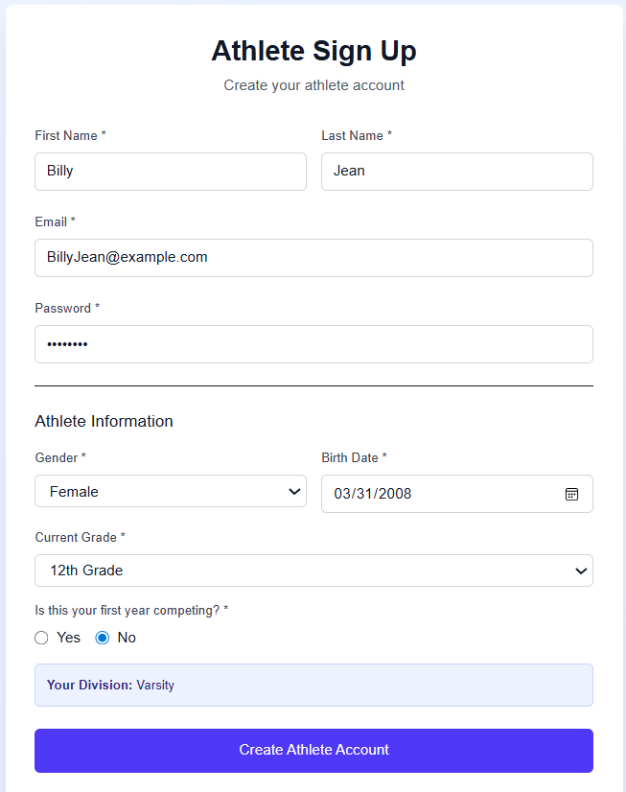

At the top of the page select the “Profile” link.
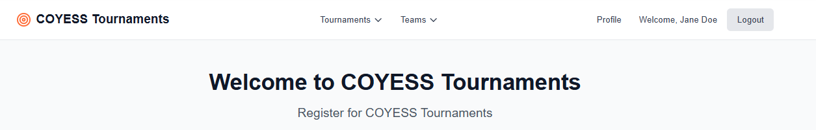

Update any profile details that are still missing. It is important to enter your phone number so we can contact you during a tournament.
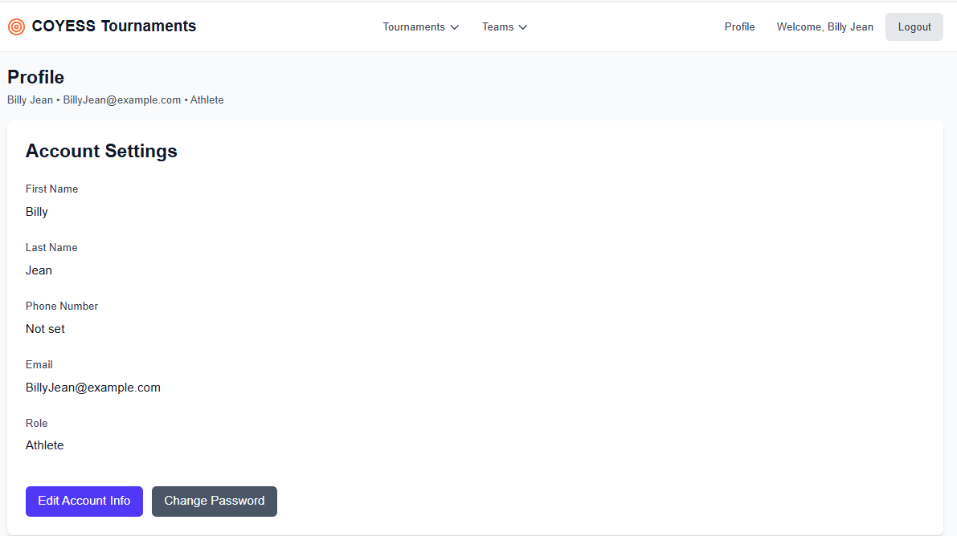
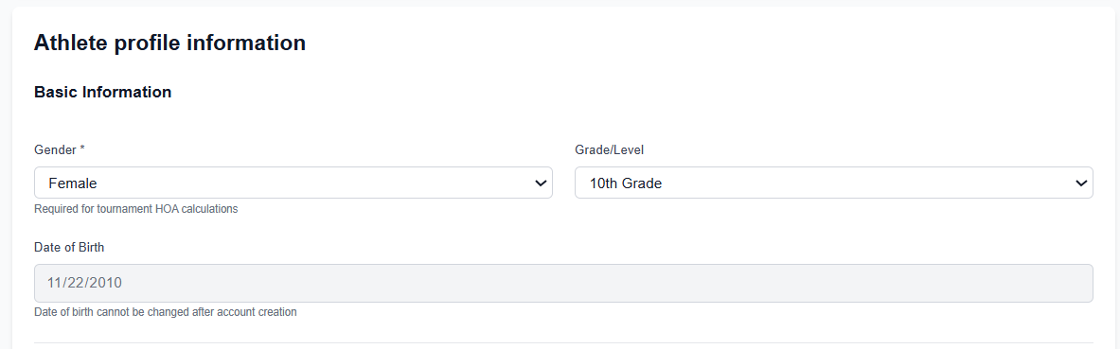

If you know your classifications and membership numbers for the national shooting organizations you can enter them. Make sure to save your profile so we record your changes.
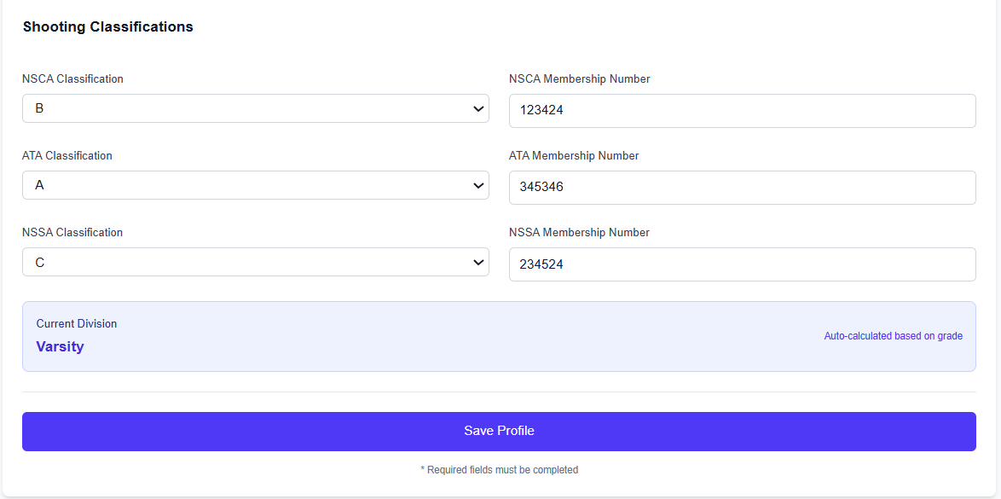

At this point you have registered as an individual athlete. You can proceed to registering for an upcoming tournament. See separate instructions for registering for tournaments.

Find a Team, Request to Join
This section will instruct an athlete on how to request to join a team. You can use this section to review the available teams, determine the head coach and possible assistant coaches of each team, and see some of the athletes that are part of each team in our system.

You will be able to request to join a team if you wish. We recommend that you do not request to join a team until you have contacted the head coach and he verbally agrees you can join the team.

Alternatively, you do not need to request to join the team. Once you are entered into the system you can let your coaches assign you to your team. We recommend if you follow this approach to message your coach separately so he knows you are in the system and should he can assign you to the team.

Go back to the top of the page and hover over the “Teams” menu to see the drop downs. You should see “Browse Teams” as a drop down under the Teams menu. Click on Browse Teams.
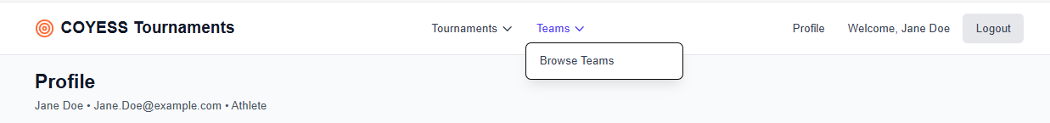

If your coach has created your team, it should be listed below. You can verify it is your team by the team name, the coaches listed, or even your teammates who have already joined. If you do not see your team name, then stop and contact your coach separately. Once he confirms the team is created you can continue below to request to join.

Select the “Request to Join” button.
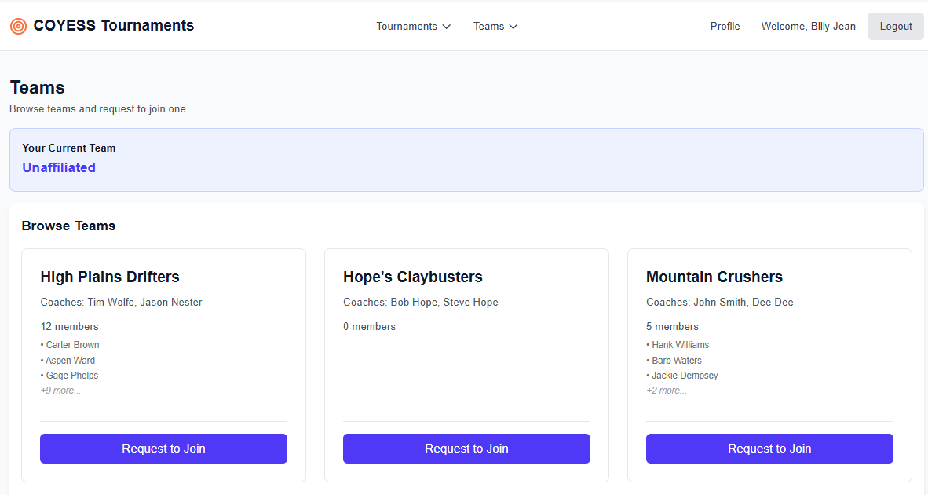

You will be prompted to send a request to join the team. You can enter a note but it is optional.
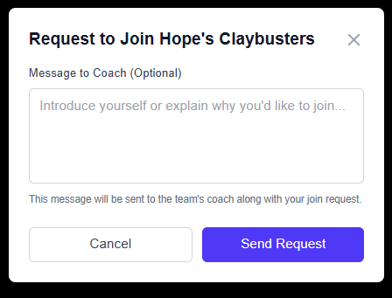

The Teams page should update and you should see a request to join a team above the list of teams. You should let your coach know you requested to join. They can then log into the system and approve your request.
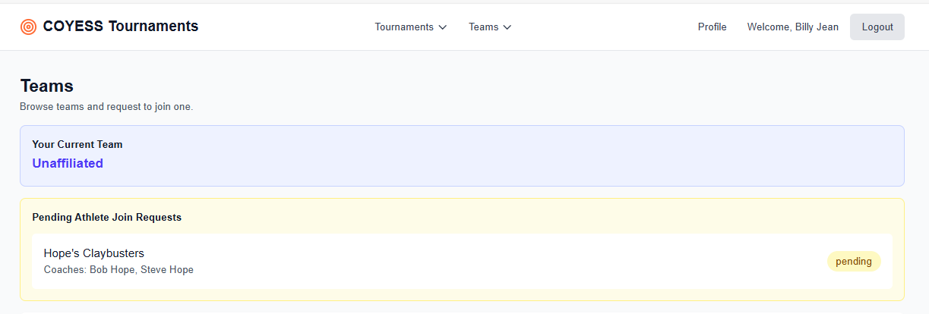

Once you are approved by the coach you will see it is approved in the system.
